**INSTALLER PACKAGING**

For packaging the installer, Select “muRataStudioSetup” project available in the Solution Explorer.

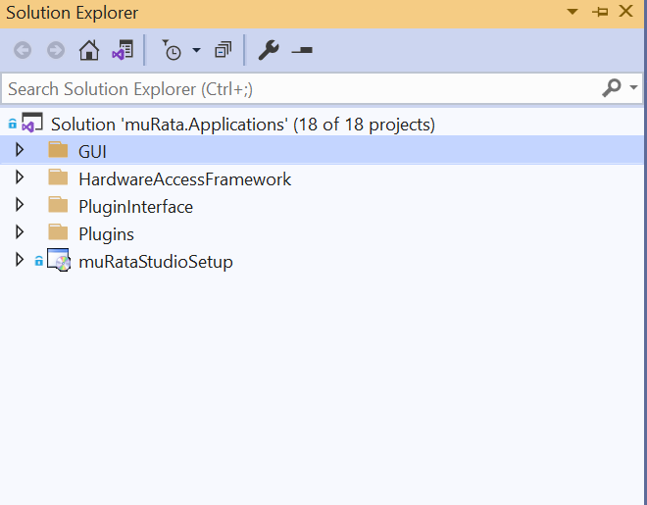

**“Installer should be packaged in Release mode”**

1) Build the solution in “Release” mode by removing the existing command line arguments in case if any exists.

1. Also make sure to confirm we have same .adz file in all the below three locations.

* [...\muratastudio\Apps\muRata\Devices]
* [...muratastudio\Apps\muRata\bin\Debug\Devices]
* [...muratastudio\Apps\muRata\bin\Release\Devices]

1. Please make sure to confirm for Plugins also

* [...\muratastudio\Apps\muRata\Devices]
* [...muratastudio\Apps\muRata\bin\Debug\Plugins]
* [...muratastudio\Apps\muRata\bin\Release\Plugins]

2) Copy the latest .adz file in

[...muratastudio\Apps\muRata\bin\Debug\Devices] to

[...muratastudio\Apps\muRata\bin\Release\Devices]

3) Build the solution in “Release” mode. After successfully Release build , select the file system editor.

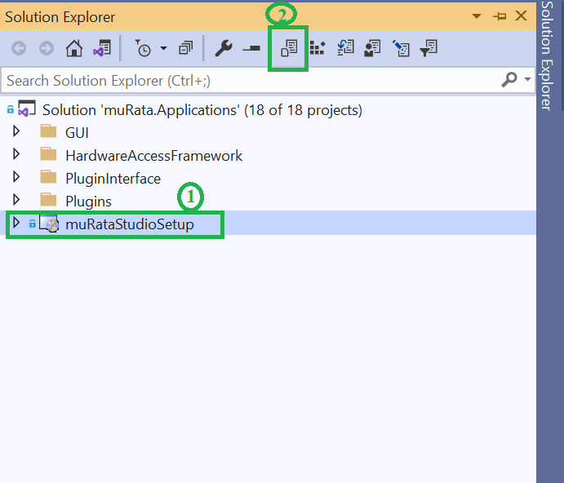

4) Following window will be opened once you select the File System Editor.

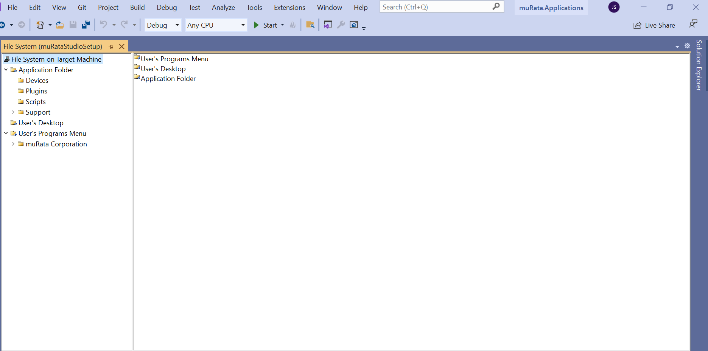

5) File System Editor window contains the following folders:

1. **Application Folder** – This folder should contain the sub folders Devices, Plugins, Scripts, Support.
   * Devices – This folder should contain the .adz’s files from Release folder of murata Project
   * Plugins - This folder should contain the .dll’s files from Release folder of murata Project
   * Scripts - This folder should contain the .xml files used for running script in Protocol Tab
   * Support – This folder is empty now.
2. **User’s Desktop** – This should contain the ‘murata Studio’ shortcut added from the Primary output
3. **User’s Program Menu**. - This should contain ‘muRata Corporation ’ sub folder and ‘muRata Studio’ sub folder inside it.

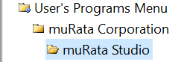

* ‘muRata Studio’ - This should contain the ‘murata Studio’ shortcut added from the Primary output

6) Select the **‘Application’** Folder . Delete the **‘Primary Output from Murata(Active)’.**

All the dll’s except the following should be removed from the Application folder

* muRata.ico
* Murata.bmp
* License.rtf
* murata Studio(Shortcut) .

If the below dll’s are still existing in the Application folder, then

* Select Devices folder and delete all the .adz files inside
* Select Plugins folder and delete all the .dll files inside
* Delete the ‘Devices’ and ‘Plugins’ folder.

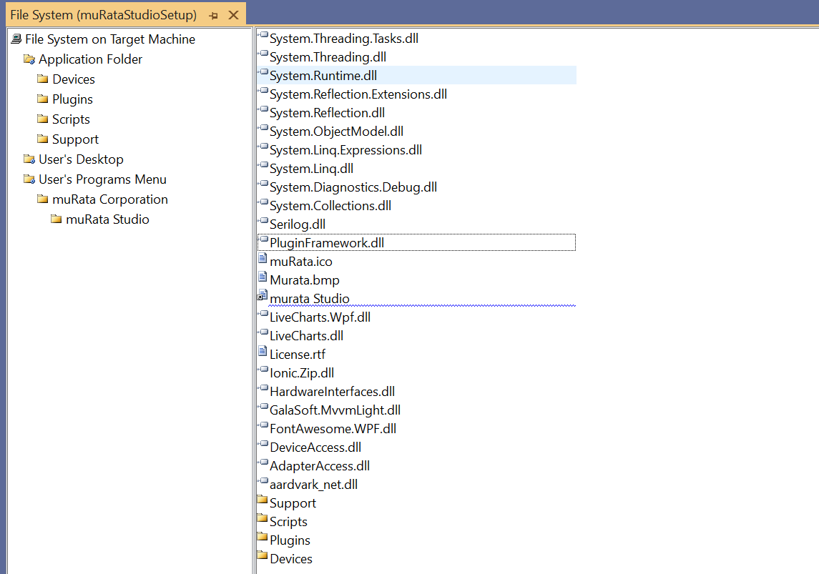

If dll’s still exist in Application folder , close and restart VS. Now all dlls will be removed .

7) Once all the preloaded dll’s are removed from Application folder, create a folder for ‘Devices’ and ‘Plugins’.

1. Right click on the ‘Devices’ Folder,
2. File → Add → Select “File” → Select .adz files from Releases/Devices folder.

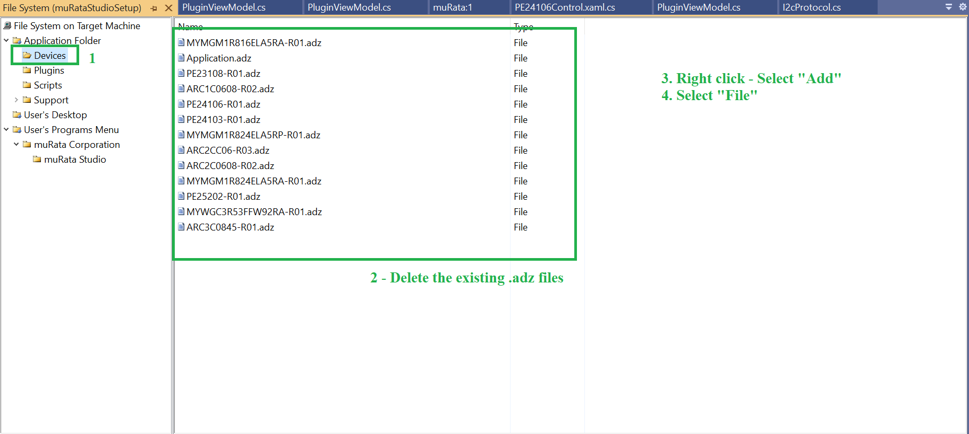

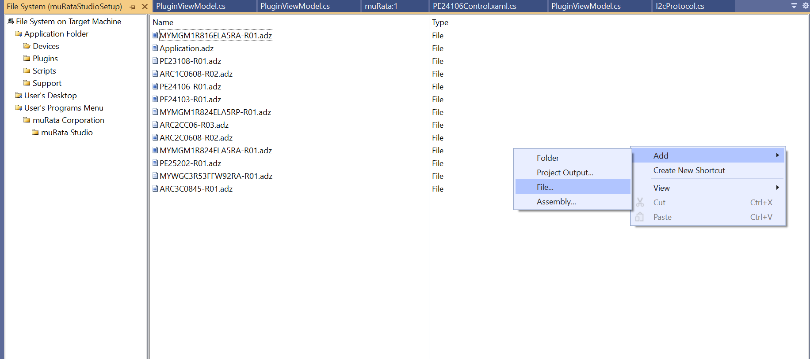

8) A new Dialog window will be opened, from which we have to load the updated .adz files

by selecting All and “Open”.

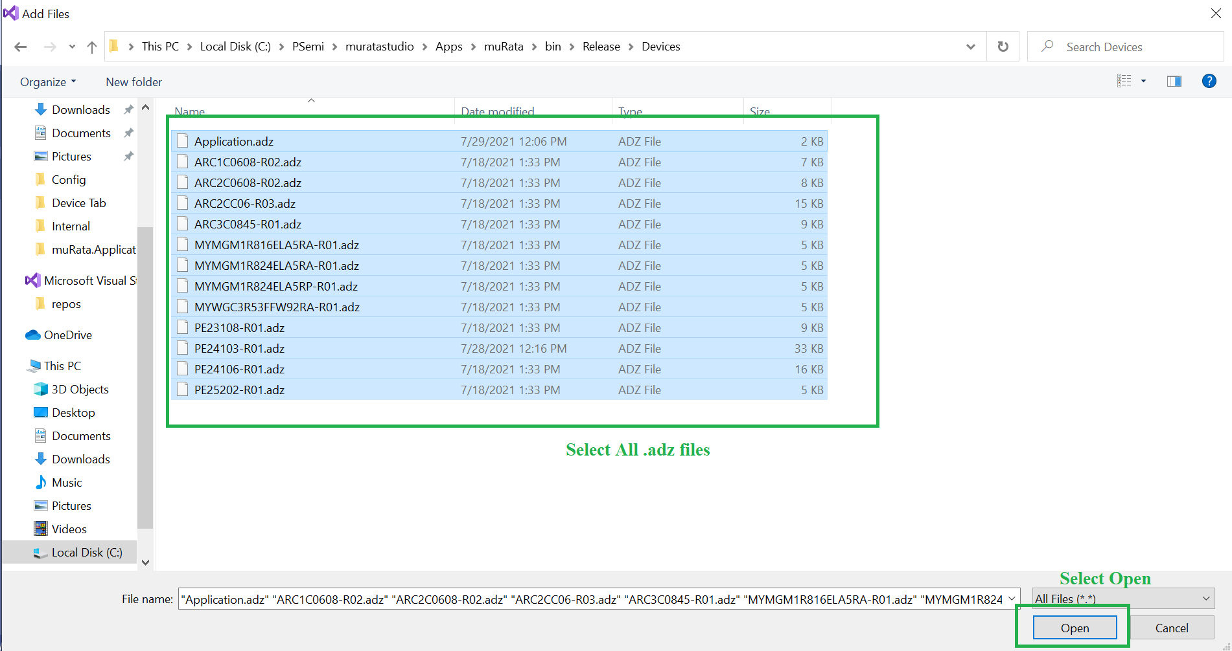

9) Click “Open”. This will update the .adz file in Device folder of file system editor.

Similarly do this for Plugins folder also.

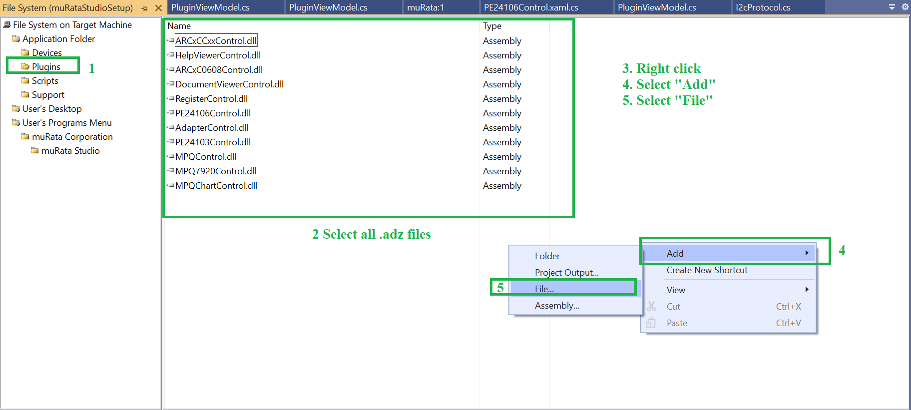

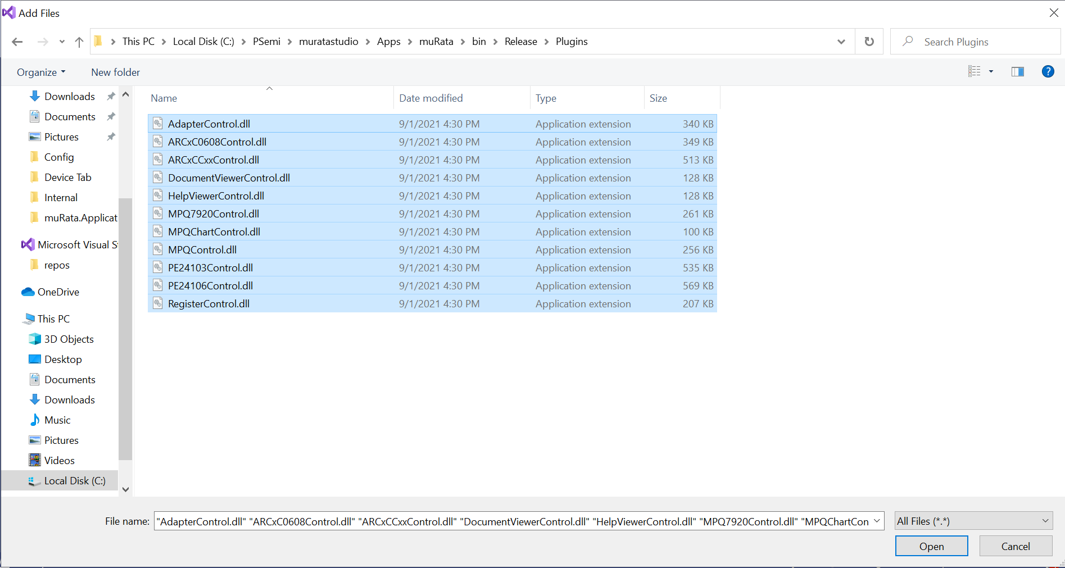

10) Click “Open”. This will update the .dll of Plugins in Plugins folder of file system editor.

11) If we have made any changes other than Plugin dll’s and device .adz files, then those changes will be reflected back in msi once we generate the primary output and its corresponding dll’s.

1. To update the following dll changes in msi, we have to add the Primary Output.
   1. AdapterAccess.dll,
   2. DeviceAccess.dll
   3. HardwareInterfaces.dll
2. To add the Project Output in Application folder,

* Right click on Application folder -> Add -> Project Output.
* Select Project as "Murata”
* Select “Primary Output” from the below list
* Configuration should be “Active”.
* Click “Ok”.
* 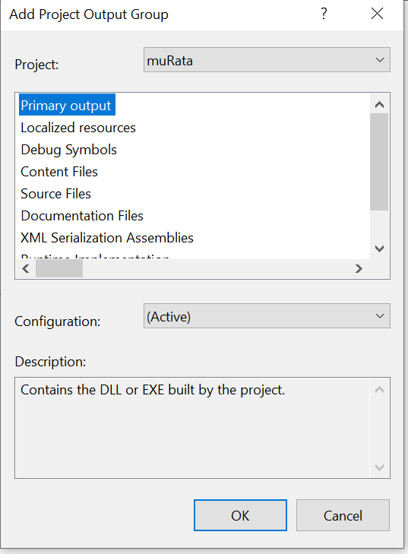

This will update the corresponding dll’s in Application folder.

14) And Once Primary output is updated in Application folder, we have to create shortcut:

* Select Application folder -> Select **Primary Output from muRata(Active)** inside the folder, Right click -> Create a shortcut from Primary Output. (follow as in below image ).

(Repeat the above step 3 times so that 3 shortcuts of Primary output are created in Application folder)

* Rename all the 3 shortcuts to “muRata Studio”.

15) Set the icon for all the 3 shortcuts to murata.ico as shown below.

Right click muRata Studio -> Select Properties Window

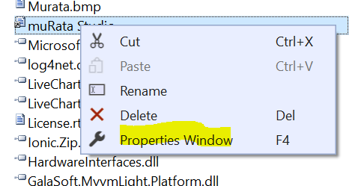

Select Icon from the window. -> Click on the yellow highlighted dropdown arrow - > Browse.

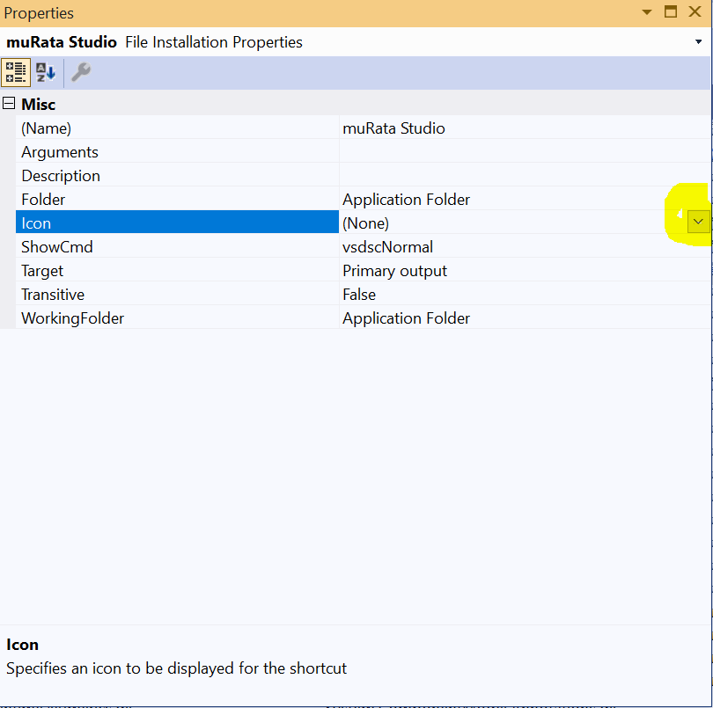

Choose murata.ico from the open window.(If murata.ico is not present inside Application folder, copy it from the muratastudio by searching the name murata.ico and place it inside application folder).

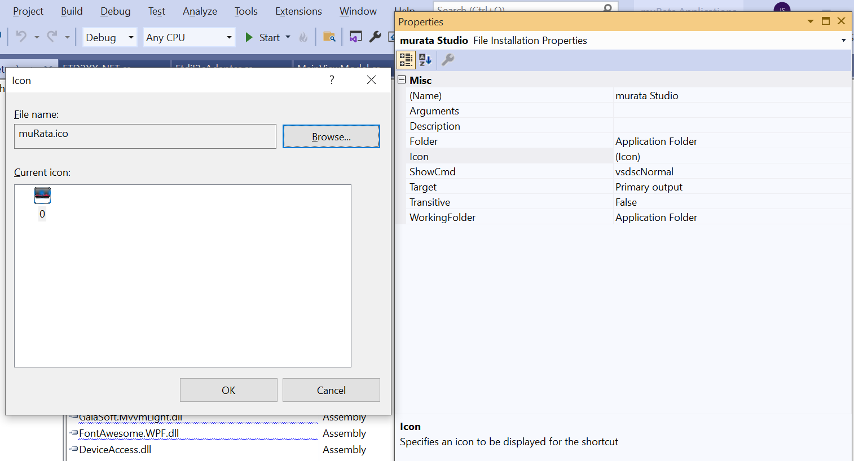

16) Once the icon is set for all the shortcuts in Application folder,

* Keep one shortcut in ‘Application Folder’ itself.
* Out of the 3 shortcuts ,copy one shortcut to ‘User’s Desktop’.
* Out of the 3 shortcuts ,copy one shortcut to User’s Program Menu-> Murata corportion -> muRata Studio.
* This will finally have

1. one muRata Studio shortcut in Application folder.
2. one muRata Studio shortcut in User’s Desktop folder.
3. one muRata Studio shortcut in User’s Program Menu-> Murata Corporation -> “muRata Studio” folder.

17) This steps above will update the File System Application folder with updated modifications on msi .

18) Now inorder to package the setup, we have to update the product code and version( need to be changed every time you build a new release. )

Select the muRataStudioSetup → Properties → Update the Version to next number by incrementing → Product code will be automatically updated once you update the Version. Last delivered version is 0.24.0, so next version to be delivered should be 0.25.0 (Instead of 1.0.4, type 0.25.0)

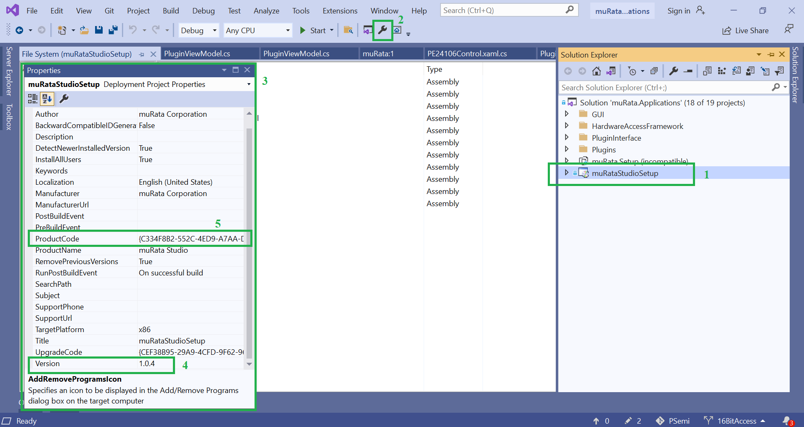

19) Additionally update the AssemblyInfo.cs file in VS Solution on to match with the Version .

For eg, if Version is 0.24.0, then AssemblyVersion should be 0.24.0.0 and similarly AssemblyFileVersion too

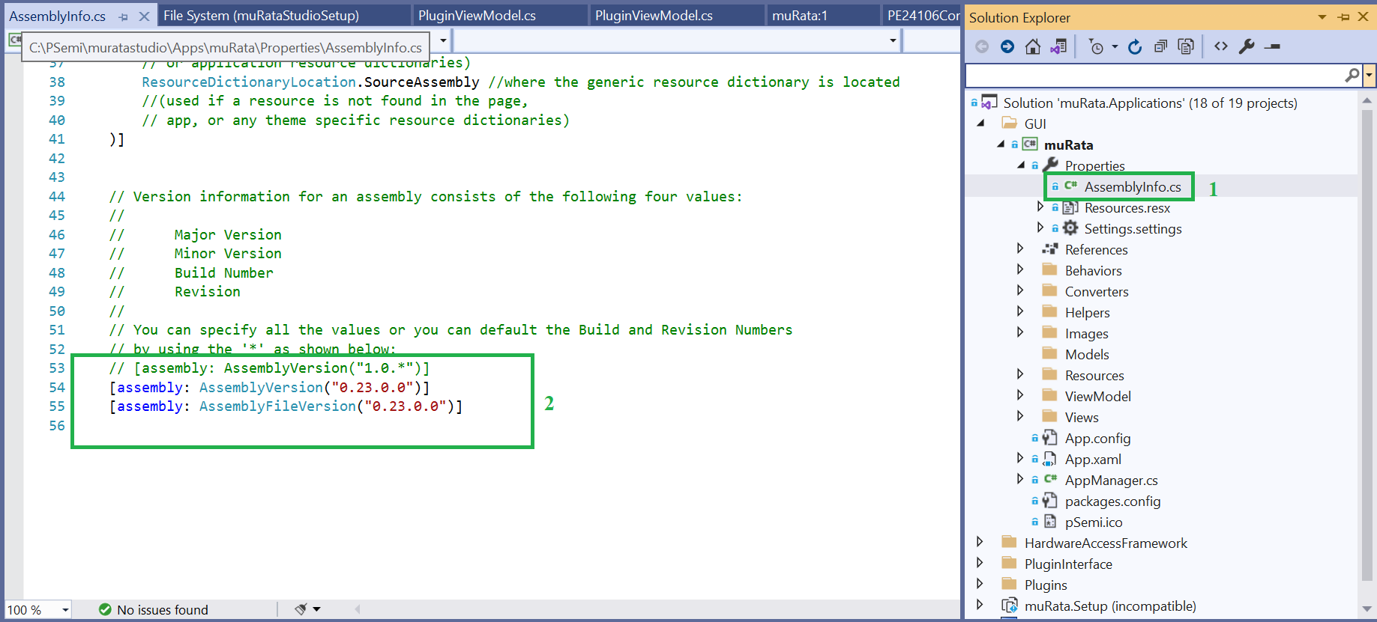

20) Once the above changes are done save it and build the solution again in Release mode .

Once the build is successful, .msi/.exe can be located at

..\muratastudio\Solutions\muRata.Applications\muRataStudioSetup\Release.

21) Install the above .msi in our PC for internal testing and verify the application functionality.

22) Once we install it, make sure to confirm the steps mentioned in Steps to verify after packaging installer.docx available in KT Guides.

23) Verify the installer Plugin dll’s are ‘latest’ by opening the installer folder in the path with the dll’s in the Release folder of the project/sln and check whether both has same timestamps( Date modified ).

24)Verify the installer .adz files( Devices) are ‘latest’ by opening the installer folder in the path with the dll’s in the Release folder of the project/sln and check whether both has same timestamps( Date modified ).

25)Verify the following files are ‘latest’ by opening the installer folder in the path with the dll’s in the Release folder of the project/sln and check whether both has same timestamps( Date modified ).

1. AdapterAccess.dll,

2. DeviceAccess.dll

3. HardwareInterfaces.dll

If the above timestamps are different, make sure to update the versions of each and every project available in VS .

For eg, to update AdapterAccess.dll, right click AdapterAccess project, Select Properties.

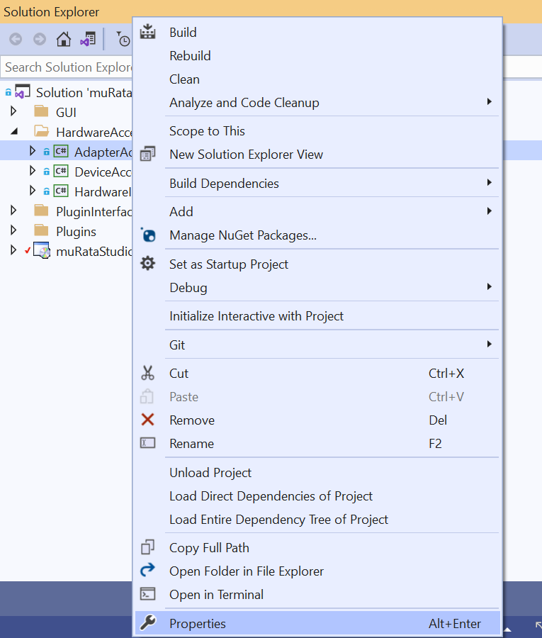

Following window will be opened .

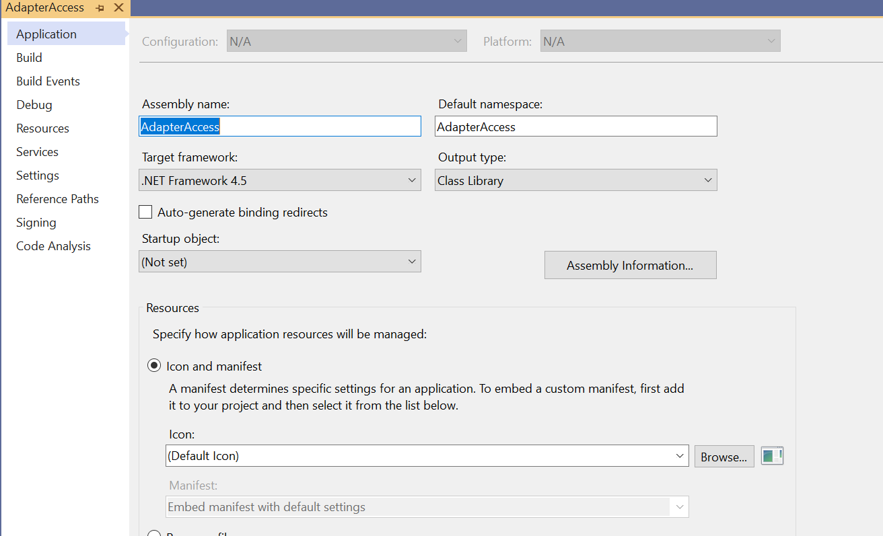

Click on Assembly Information,

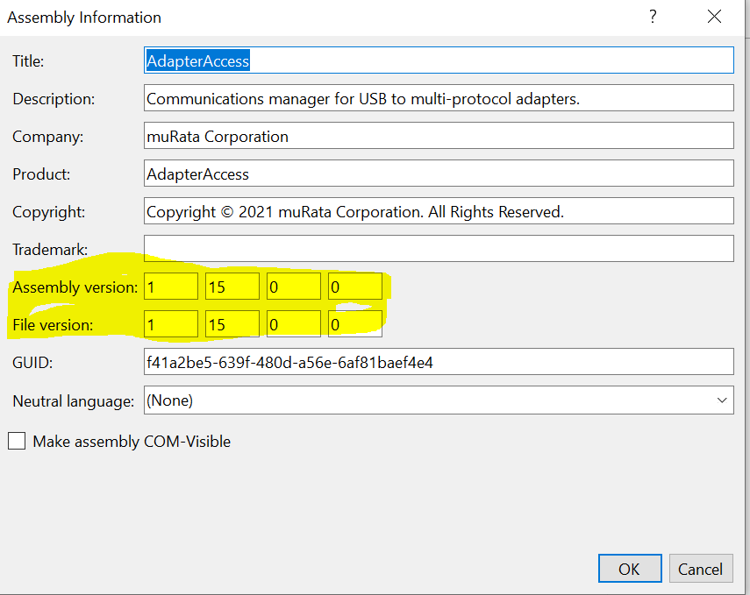

26) Update the Assembly Version and File Version by incrementing one value, so update 1.15.0.0 to 1.16.0.0 for both. Similarly to update all the dll’s that fail to update timestamp do this step for all projects.

27) If everything works as expected, Copy the .msi and .exe to a folder and zip it and share it in drop box for client access.

28) So, After we install the package, make sure shortcut is automatically created in desktop with the anme muRata Studio.

Then we have to load application with different devices.

* We have to install the package and then we have to create a new shortcut and then browse to the location (i.e. "C:\Program Files (x86)\muRata Corporation\muRata Studio\muRataStudio.exe") and append the device which we have to load in demo mode.i.e.

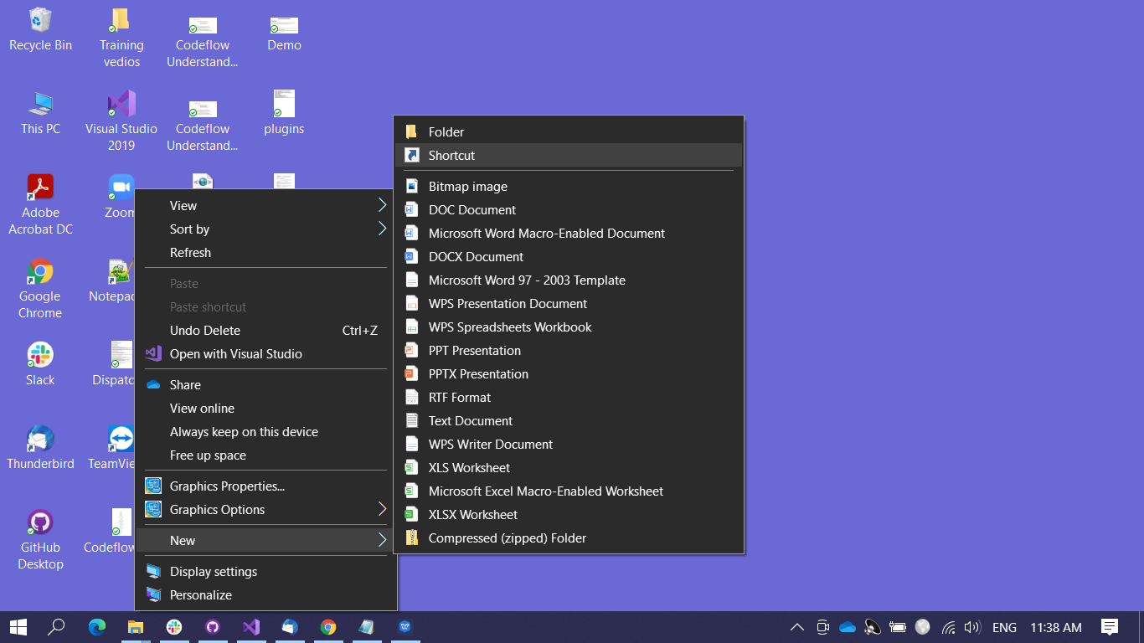"C:\Program Files (x86)\muRata Corporation\muRata Studio\muRataStudio.exe" /demo /d="ARC2CC06-R03"

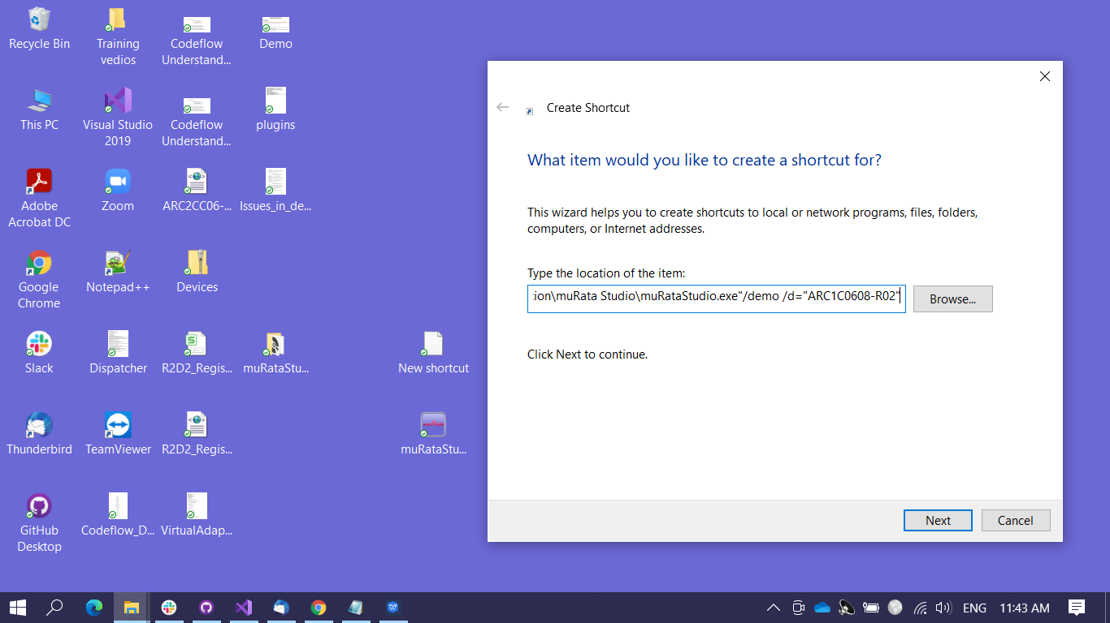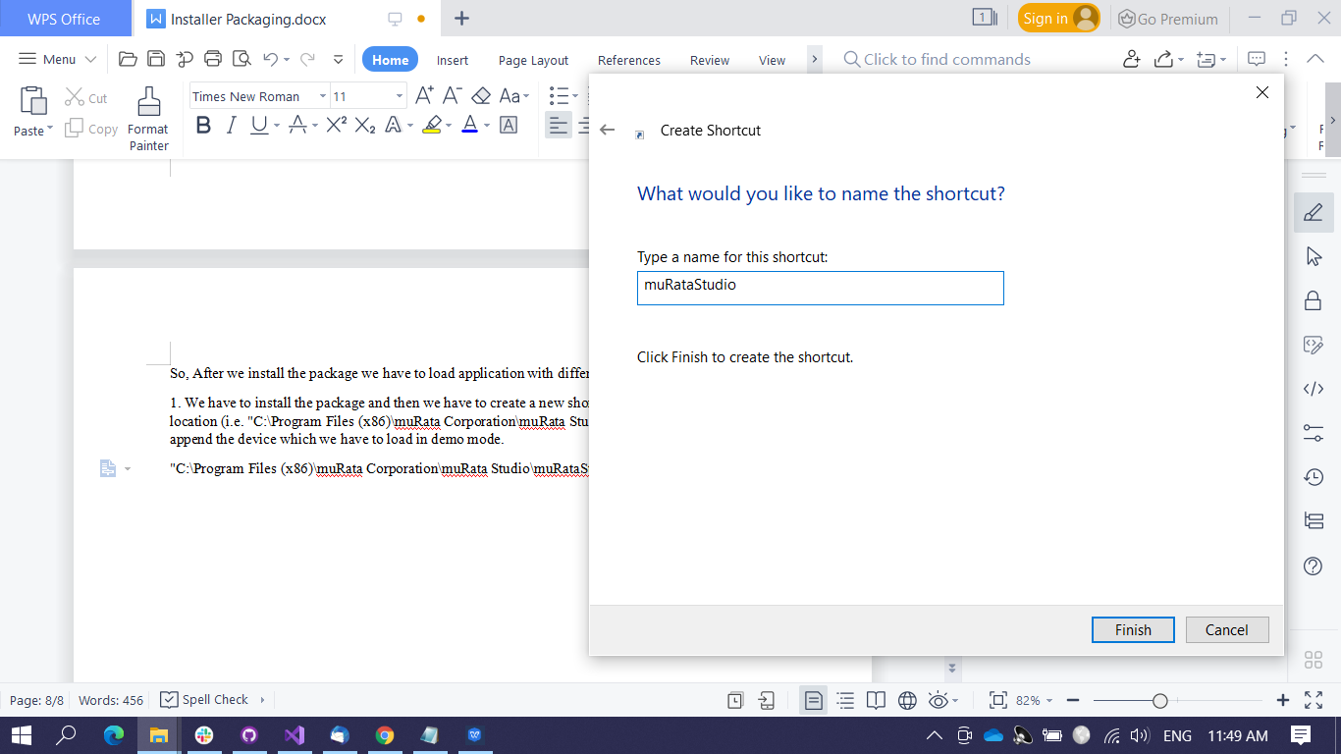

* So, Once we create the shortcut , we can launch the application.
* 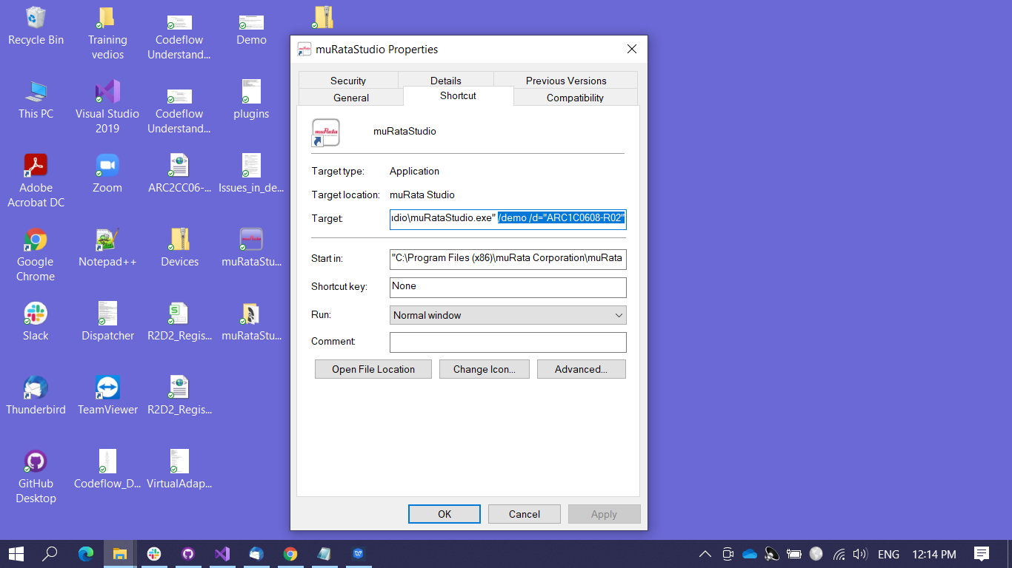If we have to load another device then, we can go to the properties of the application and append the device name to it as shown in below and then again launch the application we’ll be able to see that device is loaded.